**BUS TICKETING SYSTEM**

Introduction to Systems Development

Asia Pacific College

John Kenneth Ferrer

Chamber Jose

Rempson Dulitin

S.Y. 2015 – 2016

# Project Authors

## **Professor**

|  |  |  |
| --- | --- | --- |
| Name | Position | E-Mail |
| Mr. Manuel Sebastian S. Sanchez | Professor | manuels@apc.edu.ph |

## **Adviser/s**

|  |  |  |
| --- | --- | --- |
| Name | Position | E-Mail |
| Ms. Rhea-Luz Valbuena | Adviser | rhear@apc.edu.ph |
| Mr. Ernesto Boydon | Adviser | ernestob@apc.edu.ph |
| Mr. Jacob Catayoc | Adviser | jacobc@apc.edu.ph |
| Ms. Roselle Wednesday L. Gardon | Adviser | roselleg@apc.edu.ph |
| Mr. Jayvee Cabardo | Adviser | jayveec@apc.edu.ph |
| Ms. Maria Teresa Carmela Montemayor | Adviser | tessm@apc.edu.ph |

## **Students**

|  |  |  |
| --- | --- | --- |
| Name | Position | E-Mail |
| Ferrer, John Kenneth H. | Project Manager | jhferrer@student.apc.edu.ph |
| Jose, Chamber F. | Project Developer | cfjose@student.apc.edu.ph |
| Dulitin, Rempson P. | Project Developer | rpdulitin@student.apc.edu.ph |

**Project Description**

Bus Ticketing System is developed to contribute improvements to bus companies' transactions management. This management system allows company clients to reserve a seat / ticket, check for schedule and manage payment transaction.

**General Objectives**

* To provide passengers an efficient and easy way to reserve / book for tickets.
* To contribute improvements on client's transaction management.

**Specific Objectives**

* To provide the Client a Bus Ticketing System.
* To be paperless on client's transaction.

**Target Audience**

* Bus Companies
* Commuters

**Related Architecture**

* Project 54
* B.U.S

**Glossary**

Bus - a large vehicle that is used for carrying passengers especially along a particular route at particular times.

Bus Checker/Inspector - inspect and examine public buses for passenger usage in compliance with local and federal laws and regulations.

Bus Conductor - a person whose job is to collect fares and sell tickets on a bus.

Invoice - a nonnegotiable commercial instrument issued by a seller to a buyer.

Passenger - a person who is traveling in an automobile, bus, train, airplane, or other conveyance.

Ticket - a piece of paper that allows you to see a show, participate in an event, travel on a vehicle, etc.

Transaction - is a business event that has a monetary impact on an entity's financial statements, and is recorded as an entry in its accounting records.

Project Plan and/or Network Project Plan

**Event Table (Existing)**

|  |  |  |  |  |  |
| --- | --- | --- | --- | --- | --- |
| Event | Trigger | Source | Use Case | Response | Destination |
| Customer wants to check ticket availability | Item Inquiry | Customer | Look ups for Ticket Availability | Item Availability Details | Clerk  Customer |
| Customer buys ticket | New Transaction | Customer | Customer buys Ticket | Ticket Allotment | Customer |
| Produces Customer Ticket | Completed Transaction with the Customer | Conductor/Terminal | Provides Ticket | Ticket Details | Customer |
| Checker verifies the passenger for tickets | Ticket Checking | Checker | Checks Tickets | Ticket | Customer |
| Conductor balances the ticket payments and sends it to the terminal | Payment Balancing | Conductor | Balances payment | Payments and Tickets | Accounting / Finance |
| Produces Order Transaction Reports | End of the Week, Month, Quarter or Year | Accounting | Produces Order Transaction Reports | Order Transaction Reports | Manager |

**Use Case Diagram**

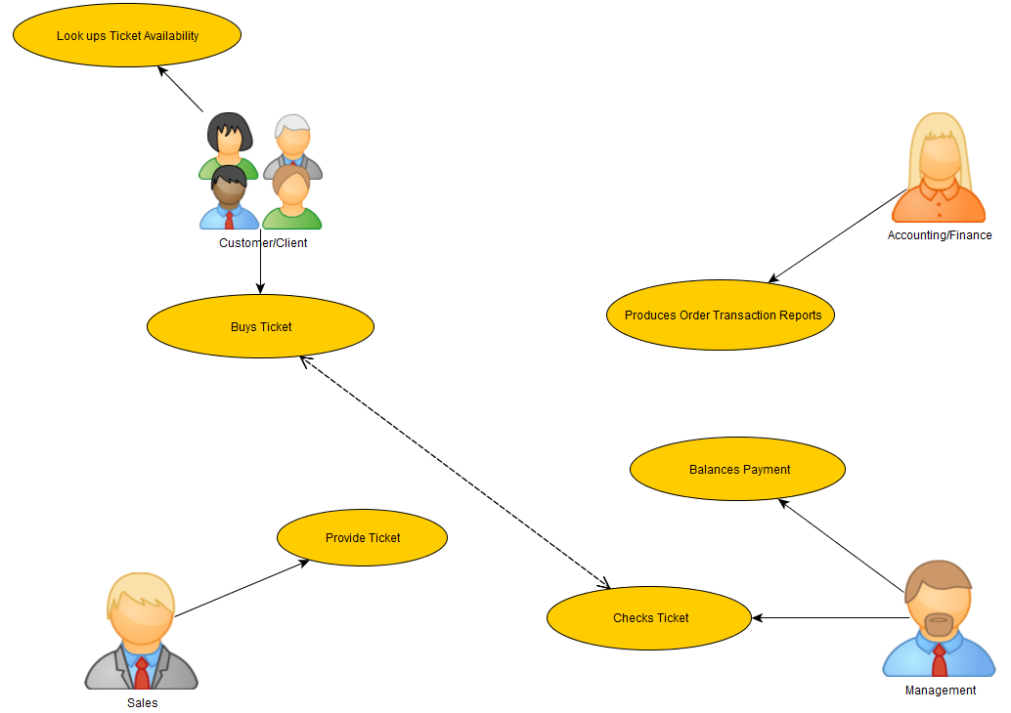

#### **Use Case Full Description**

|  |  |
| --- | --- |
| Use Case Name: | Look ups Ticket Availability |
| Scenario: | Look up ticket availability |
| Triggering Event: | Item and service inquiry |
| Brief Description: | When customer calls to inquire, the clerk will check the system for ticket availability and inform the customer about the details |
| Actors: | Customer and Telephone Sales Clerk |
| Related Use Case: |  |
| Stakeholders: | Sales Department to provide ticket availability details |
| Preconditions: | Customer asks for ticket availability details Customer must exist |
| Post-conditions: | Customer acquires the information about the availability and he/she can choose to buy a ticket |
| Flow of Activities: | |  |  | | --- | --- | | Actor | System | | 1)Sales clerk answers the telephone and start to talk to customer |  | | 2) Clerk asks the customer his/her concern |  | | 3) Customer inquiries for ticket availability |  | | 4) Clerk verifies the availability into the system | 4.1 Displays ticket availability | | 5) Clerk informs the customer about the ticket availability details |  | | 6) Customer indicates end of inquiry; Clerk will now end the transaction |  | | 7) The customer may choose to buy a ticket |  | |
| Exception Conditions: |  |

|  |  |
| --- | --- |
| Use Case Name: | Customer buys ticket |
| Scenario: | Customer performs a transaction |
| Triggering Event: | New transaction |
| Brief Description: | When customer calls / go to terminal to buy tickets, the clerk will ask for the customer’s information, the total number of tickets to avail and the destination |
| Actors: | Customer and Telephone Sales Clerk |
| Related Use Case: | Provides ticket |
| Stakeholders: | Sales Department to provide ticket availability details finance to transact with the customer for ticket payment |
| Preconditions: | Customer had an idea on his/her travel schedule |
| Post-conditions: | Customer has successfully bought a ticket |
| Flow of Activities: | |  |  | | --- | --- | | Actor | System | | 1) Clerk asks the customer's information. |  | | 2) Customer has to pay to the finance to get the ticket. | 2.1 Receives Payment | | 3) Clerk indicates the end of the transaction. |  | |
| Exception Conditions: |  |

|  |  |
| --- | --- |
| Use Case Name: | Provides ticket |
| Scenario: | The customer gets the ticket |
| Triggering Event: | Completed transaction with the customer |
| Brief Description: | When the customer has paid the amount, he/she will be given a ticket |
| Actors: | Customer and Telephone Sales Clerk / Conductor |
| Related Use Case: | Produce transaction summary reports |
| Stakeholders: | Finance to transact with the customer for ticket payment  Sales / Conductor to provide ticket to customer  Accounting to record the transactions performed by the finance department |
| Preconditions: | Customer has to pay the amount to the terminal / conductor |
| Post-conditions: | Ticket has been given and received by the customer, company-to-customer transaction is completed |
| Flow of Activities: | |  |  | | --- | --- | | Actor | System | | 1) After the transaction, the ticket will be given to the customer and sales report will be sent to the management | 1.1 Provide Ticket | |
| Exception Conditions: |  |

|  |  |
| --- | --- |
| Use Case Name: | Checks Tickets |
| Scenario: | Checker inspects the passenger's ticket |
| Triggering Event: | Ticket checking |
| Brief Description: | After buying the ticket, passenger should keep his/her ticket for inspection which will be done by the checker |
| Actors: | Customer & Checker / Inspector |
| Related Use Case: | Balances payment |
| Stakeholders: | Checker to inspect the customer's ticket |
| Preconditions: | Customer must have his / her own ticket |
| Post-conditions: | Checker must able to check all the tickets of the passenger, confirmation or proof if a passenger really bought a ticket and it is valid |
| Flow of Activities: | |  |  | | --- | --- | | Actor | System | | 1) Checker asks for customer's ticket |  | | 2) Customer hands over the ticket |  | | 3) Checker inspects the ticket |  | |
| Exception Conditions: | 3.1 If the customer hasn't yet bought a ticket while the inspector is checking for the passenger's ticket, he / she is required to avail one |

|  |  |
| --- | --- |
| Use Case Name: | Balances Payment |
| Scenario: | Conductor balances the payments |
| Triggering Event: | Balancing of payment |
| Brief Description: | After counting ticket payments , conductor balances ticket payments and send it to the terminal |
| Actors: | Conductor and Accounting / Finance |
| Related Use Case: | Produce transaction reports |
| Stakeholders: | Conductor to balance the ticket payments  Accounting/Finance to record the payments |
| Preconditions: | Ticket payments should match with the ticket sold |
| Post-conditions: | Ticket payments are sent to terminal and will be recorded by accounting/finance |
| Flow of Activities: | |  |  | | --- | --- | | Actor | System | | 1) Conductor counts the payments |  | | 2) Conductor sends the ticket payments to the terminal / management |  | |
| Exception Conditions: |  |

|  |  |
| --- | --- |
| Use Case Name: | Produce Transaction Summary Reports |
| Scenario: | Produce transaction summary reports |
| Triggering Event: | End of the day |
| Brief Description: | At the end of the day, the accounting department gathers all transactions recorded by the system and employees to evaluate the report. |
| Actors: | Accounting Department Employees |
| Related Use Case: | None |
| Stakeholders: | Accounting to process the reports |
| Preconditions: | Accounting will extract all the transactional records from the system |
| Post-conditions: | Records are gathered from the system and is ready to be evaluated by different departments of organization |
| Flow of Activities: | |  |  | | --- | --- | | Actor | System | | 1) Accounting gather transactional records | 1.1 Displays transactional records | |
| Exception Conditions: |  |

### Context Diagram

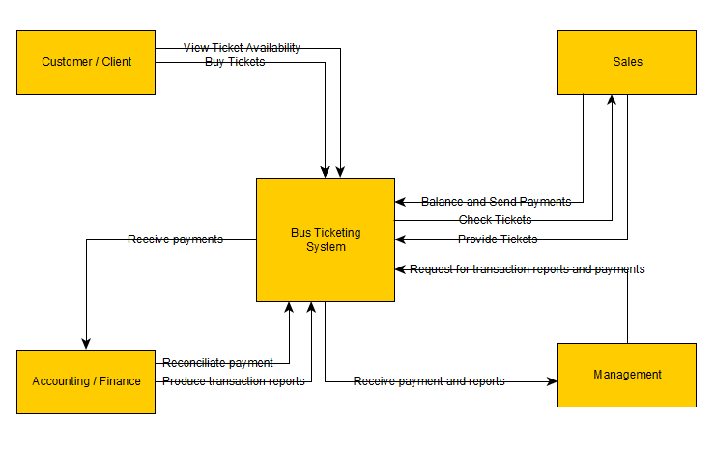

### Data Flow Diagram

#### C:\Users\Makati\Desktop\DFD Level 0 (Final).jpgLEVEL 0

#### C:\Users\Makati\Desktop\DFD Level 1 (Final).jpgLEVEL 1

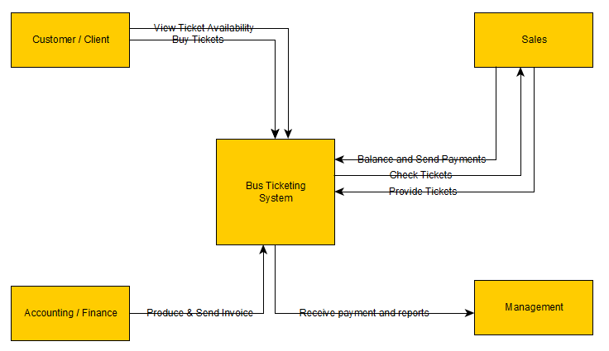Entity Relationship Diagrams

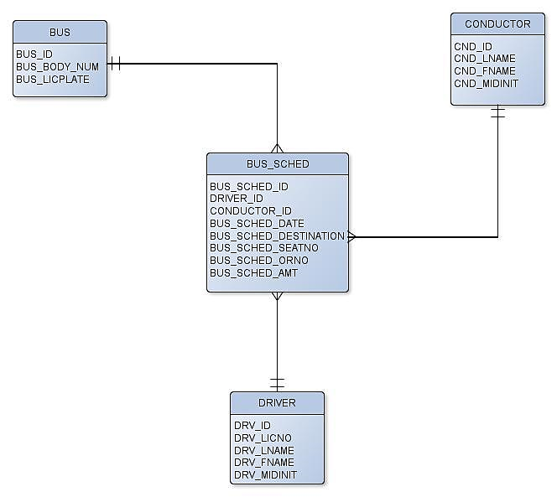

used

handle

facilitate

Activity Diagram

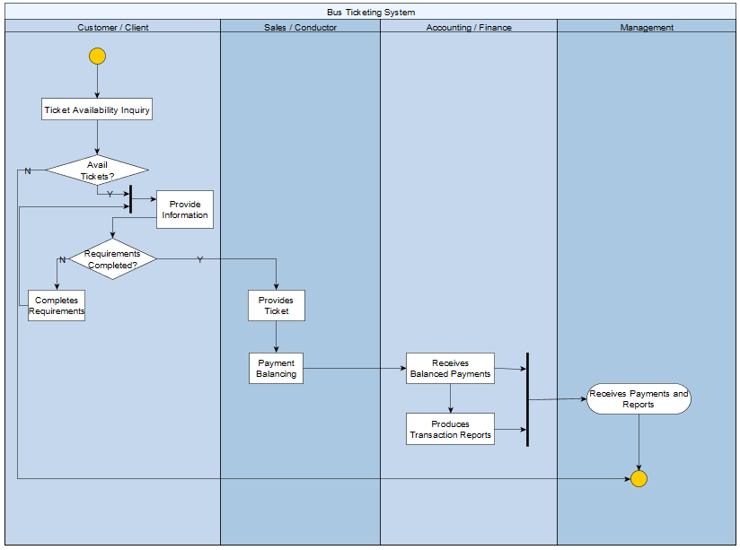

**Data Dictionary**

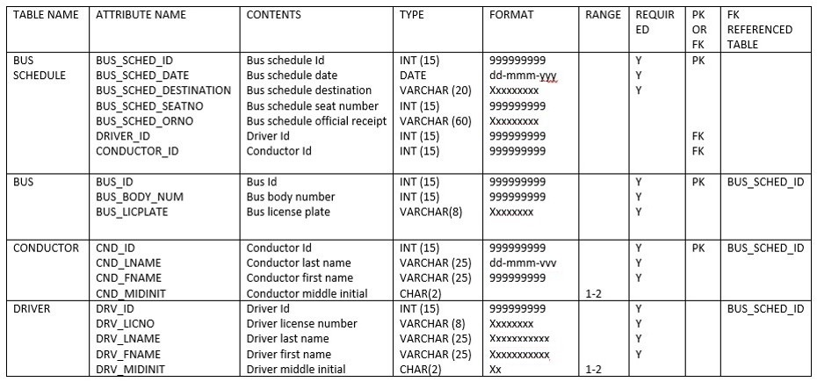

**Gantt chart / WBS / Activity List**

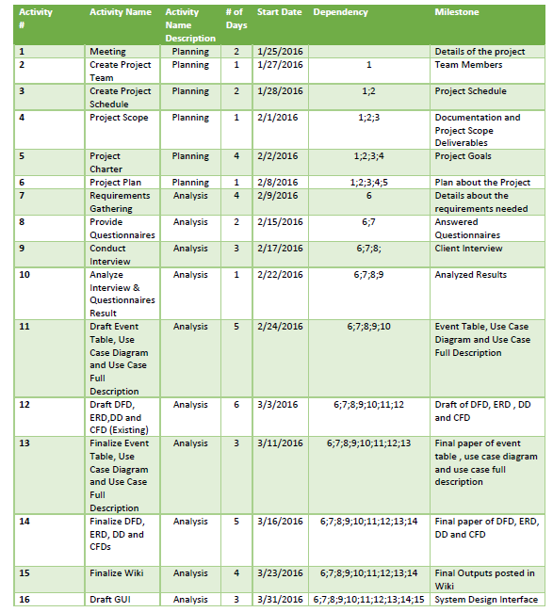

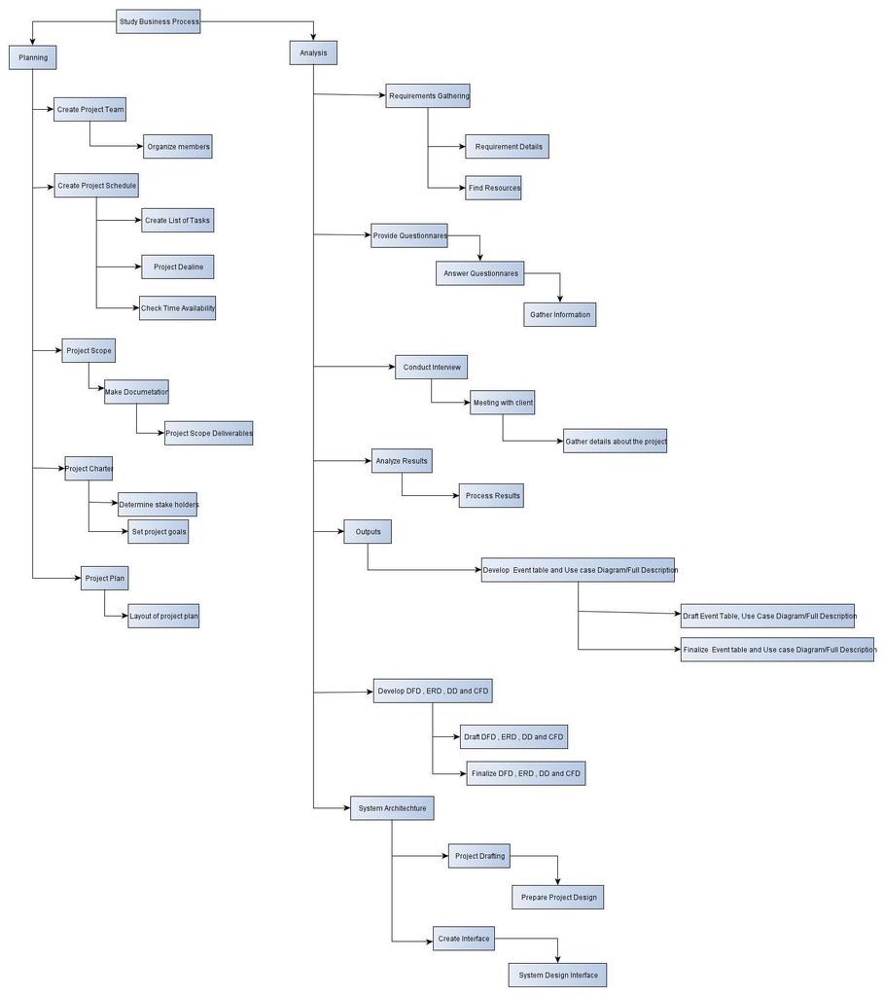Work Breakdown Structure (WBS)

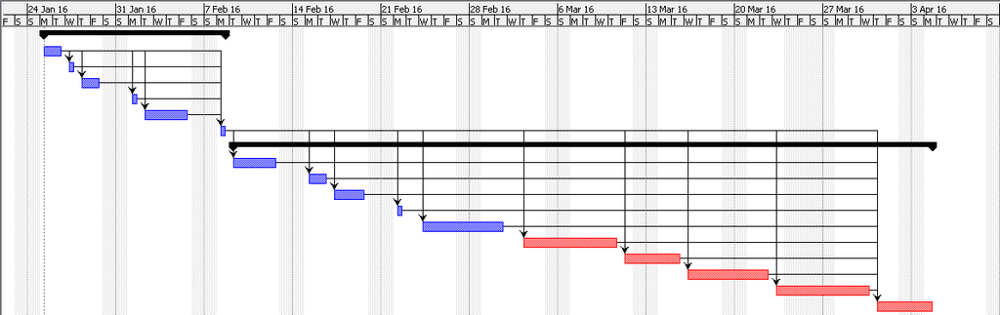Gantt chart

### Screenshots of Proposed System

